


Solutions Flash

Wireless Exchange Solutions from Compaq® and InfoWave™

Looking for a secure and reliable way to wirelessly extend Microsoft® Exchange® to mobile workers? Compaq and InfoWave have teamed up to provide a solution that offers mobile workers the ability to stay connected to their Exchange server over a nationwide wireless data network using their Compaq Armada or ProSignia notebooks, Aero handhelds, or iPAQ Pocket PCs.

With Infowave for Exchange, Outlook® or Pocket Outlook users can easily access their corporate Exchange server over a fast, nation-wide wireless data network. When coupled with Compaq ProLiant servers and range of clients, and the full range of Exchange deployment services, Compaq and InfoWave further extend the NonStop™ Exchange environment to include wireless access.

Features and Benefits

Exchange/Outlook Integration  Infowave for Exchange is tightly integrated on the server side with Microsoft Exchange server and on the client side with Outlook and Pocket Outlook. Users do not require any special training since they are using the same Outlook or Pocket Outlook applications that they already know.  Enterprise-level Security  NTLM challenge response authentication is used to certify each user during log on. Strong encryption via Certicom's Elliptical Curve and DESX ensures secure end-to-end data security.  Efficiency & Optimization  Message delivery is optimized through protocol efficiencies and data compression. As well, all unnecessary data is stripped from email messages so that only the minimum amount of information is sent over the wireless link. | NonStop Messaging Environment  Compaq Knowledge Management And Messaging NonStop™ eBusiness solutions are designed to bring your enterprise into the new millennium, with ease. We are prepared to take your Knowledge Management & Messaging environment to the highest levels of continuous commerce with:  - World Record Setting Hardware Performance  - Award-winning Services  - Strong partnership with Microsoft, including Prime Integrator status for Exchange Server 2000  Management Features  Infowave for Exchange allows network administrators to easily track, control, monitor and manage their mobile users. For example, an existing Exchange user can be made wireless by simply clicking a check box in the Exchange Administrator program.

Requirements
Enterprise  Wireless  Users | Activity  Level | Recommended  Server | LAN | RAM | Disk  Controller
1 – 50 | 25% | ProLiant ML370 P667-256K | 10 Mbit | 128MB | SmartArray 431
51 – 250 | 25% | ProLiant ML370 P667-256K | 10 Mbit | 128MB | SmartArray 431
251 – 500 | 25% | ProLiant ML370 P667-256K | 10 Mbit | 128MB | SmartArray 431
501 – 1000* | 25% | ProLiant ML370 P667-256K | 10 Mbit | 256MB | SmartArray 431
*It is assumed that a maximum of 25% of wireless users are connected to the server at any given time.

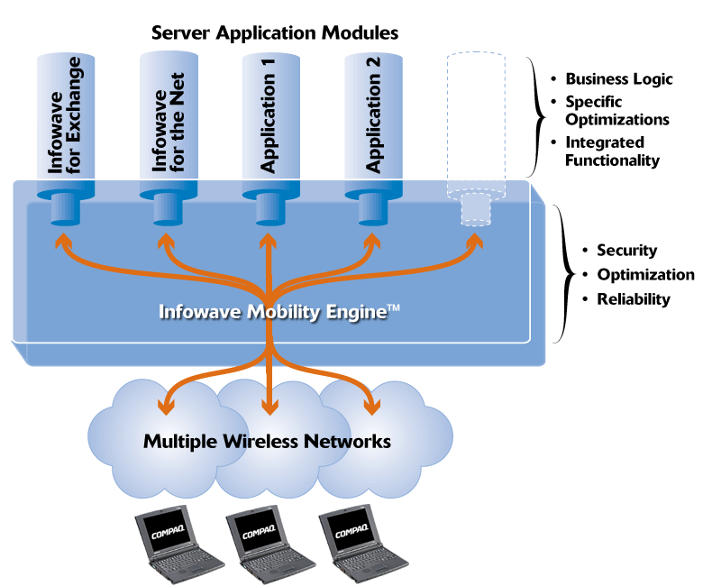
The Mobility engine will support a maximum of 247 simultaneous Exchange connections. We have assumed a certain level of activity for users (that is, the percentage of users actively involved in data transfer at any given time).

Infowave for Exchange utilizes the Infowave Mobility Engine, which ensures a reliable connection to the wireless networks as well as security and network optimizations features. The Mobility Engine and the Infowave Exchange module can be located on different machines in order to increase scalability and distribute load.

Example
In the case of 1000 wireless users, we assume that a maximum of 247 users are connected to the server at any given time (a 25% duty cycle). Of the 247 connected users, the number of users that are actively performing a data transfer is given by the activity level in the table.

Client Requirements

Client Hardware
- Aero 8000
- iPAQ H3600 Pocket PC
- Armada Family of Notebooks
- ProSignia Family of Notebooks

Client Software
- Microsoft Outlook or Microsoft Pocket Outlook
- Internet Explorer 5.0
or later or Pocket Internet Explorer
- Netscape Navigator 4.5 or later

Connectivity Requirements

Wireless Network Carrier
- AT&T
- W.I.S.P
- GTE
- Verizon Wireless


Wireless Device
- Sierra Wireless Aircard 300 (recommended)

Other CDPD modems

